QUIZ/TEST CORRECTIONS

-For all problems reworked, students must show all work proving their new answer (if “work” is not required, a detailed explanation or model is required).

-Students must also include an “error analysis” for each problem missed. The analysis explains in writing what mistake was made for the problem on the original test. The following “error analysis” responses will not be accepted resulting in no partial credit earned back:
-I solved the problem incorrectly.
-I didn’t know how to do it.
-I guessed.

-All work must be completed in pencil, problems numbered, solved out neatly, answer circled, error analysis present and completed on a separate sheet of paper set up as shown below in order to possibly earn back ½ credit:

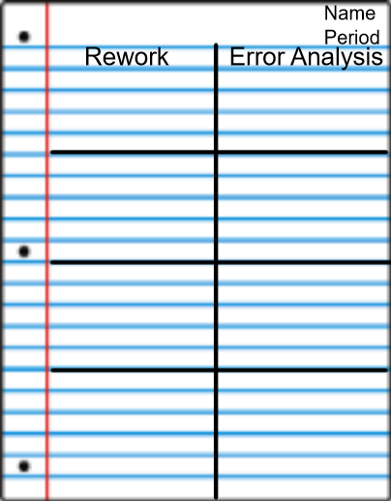

-Students may utilize notes posted on my website smithatlcma.weebly.com, on-line book and resources, tutors, parents, siblings, etc. As a teacher, I am very willing to help the student, but in order for the student to earn back ½ credit, he/she must use self-discovery.

-The rework piece of notebook paper must be stapled to the front (on top) of the original test. Failure to follow the procedures listed about may result in no partial credit being earned back (this includes failure to use a pencil).

-The reworked test must be turned in on the due date stated. No late reworks will be accepted unless there has been an excused absence.

